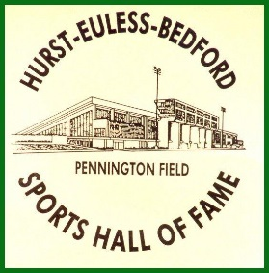
HEB Sports Hall of Fame
Pennington Field
Vickie Griffin, Executive Director
hebshf@gmail.com

.

Your Organization’s Letterhead

Insert Date

Dear

Our first annual HEB Sports Hall of Fame Golf Classic will take place on Monday, September 19, 2016 at Texas Star. This year’s Golf Classic will be called the “Nellie Moore Golf Classic.” Our goal is to raise $30,000 dollars that will be used for scholarships to help the athletes with their college expenses. In order to meet this goal, we are asking for sponsorships from local businesses and individuals such as yourself.

By giving to this annual event you'll be supporting the HEB Sports Hall of Fame and helping us provide assistance to the athletic students in need within our community. We ask that you will consider a sponsorship donation of $10,000 Platinum Level, $5,000 Gold, $3,000 Silver and $1,000 Bronze. As a platinum, gold, silver or bronze sponsor, your donation will be recognized at our event in several ways. As a sponsor, your name will be placed on all materials and banners that publicize the event, as well as, announced verbally at the tournament event and the HEB Sports Hall of Fame Banquet. The deadline to submit sponsor informational for promotional materials and/or signs is September 1, 2016.

We hope that we can count on you to help support our goal. You will be contacted in the next several days. If you have any questions or concerns in the meantime, please feel free to contact us at hebshf@gmail.com.

Thanks in advance for your consideration!
Sincerely,

HEB Sports Hall of Fame Board Member

HEB Sports Hall of Fame is a registered charitable 501c3 tax deductible organization. The HEB-SHF Tax EIN# 75-2592863.

